Directory

Physical AI Introduction(V1.3.1) 1

How to set up 2

Make physical AI with your own models 3

Make a self-collision animator 4

Use your own animations 5

Special notes on stand-up animations 5

Write your own AI 6

# Physical AI Introduction(V1.3.1)

-Physically based character animation performance with internal collision option

-One click creates humanoid dynamic ragdolls and automatically calculates joint limits.

-Automatic setting of joint spring and damper based on total mass, achieving good dynamic ragdoll performance without manual adjustment.

-Provide sample player and AI scripts with basic state transitions and damage calculation system(including falling damage).

# How to set up

1. Import the resource package
2. 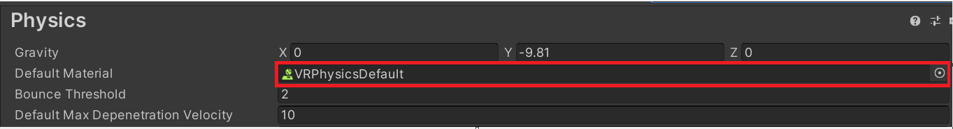Set ‘VRPhysicsDefault’ as your default physics material.
3. 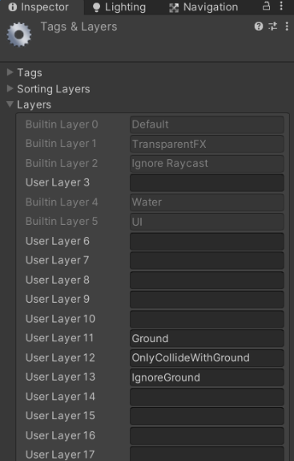Add Layer, as shown in the figure
4. 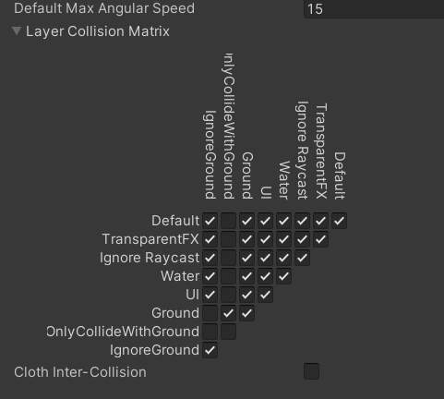Set Default Max Angular Speed to 15 in Project settings-Physics
5. Run it and add the missing tag according to the error
6. Add ‘Ground’ layer to all the floors.

# Make physical AI with your own models

1. Import the model (make sure it is T-pose, otherwise the joint restrictions cannot be automatically generated correctly)
2. 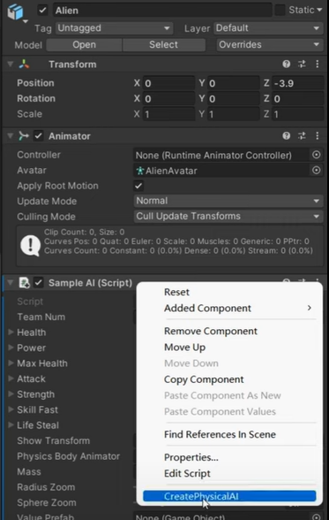Drag the model into the scene, add the 'SampleAI' script, and right click to execute the 'CreatepPhyscialAI' function. Body rigidbodies, colliders, and joints are automatically generated at this point, and joint constraints have been automatically calculated. Joint spring and damper are calculated automatically at runtime.
3. Sample AI has some basic states. If you have no special requirements for AI, you can directly use this script to make your game.
4. Put your mouse on the parameters in the inspector. If it is an important parameter, there will be a tip.

# Make a self-collision animator

1. The process is similar to making physicalAI. Drag the model into the scene, add the 'SelfCollisionAnimatorI' script, and right click to execute the 'CreatepPhyscialAI' function.
2. Now you can add your own control script to the game object named ‘RealBodyAnimator’.

# Use your own animations

1. 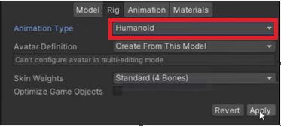Set the animation type to Humanoid and click apply
2. Bake the root transform postion(Y) of animation into pose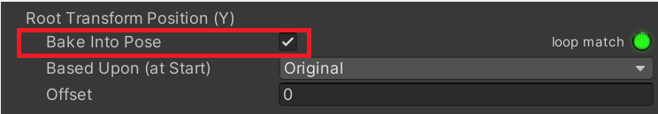

## Special notes on stand-up animations

1. There should be a transition from the break state to the standup state (see the sample state machine)
2. 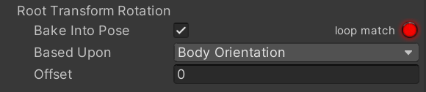Whether it is a break state or a standup state, the root rotation should be baked into pose.
3. 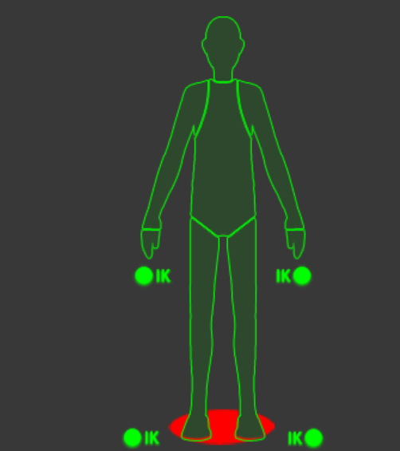You can set a mask for your ‘break’ animation.

# Write your own AI

**AI has four physical states:**

***Kinematic.***

***Dynamic:*** Controlled by configurable joints. Freeze rotation of lower body to ensure normal walking posture. Using ‘move position and rotation’ for body center. Simulate gravity with character controller.

***Free:*** Normal Ragdoll, activated on death.

***PartialDynamic:*** All controlled by configurable joints. No forced movement for body center . Enable rigidbody gravity. Mainly used for falling state.

Increasing ***‘densityZoom’*** makes AI more powerful.

During state transitions, you need to select the appropriate physical state. You can make your own physical character controller or AI by inheriting ***‘CompletePhysicalBody’*** script. Then refer to the script ***‘PhysicalAI’*** and ***‘SampleAI’.***

You can watch the instructional video on the asset store page to get a step-by-step guide. Pay attention to the version, some may be outdated. If there is a difference, refer to the latest version of the instructions.

Welcome to [my discord](https://discord.gg/3FYnhMCxQW).

If you have any questions, please contact my email: [vrnightcrawler@gmail.com](mailto:vrnightcrawler@gmail.com)